**Deliverable 2**

Report Date: 2023.10.19

**1. Work in Progress:**

Our team has made significant progress in the development of our project---Bubble Teahouse Management System.

The WPF interfaces are almost finished and just require minor polishing.

Key functionalities implemented by this stage:

1. Process Order:

The "Process Order" functionality allows customers to select their desired bubble tea items from the menu.

Customers can customize their order by choosing the type of tea, flavor, sweetness level, and ice quantity.

Once the order is customized, customers can add it to their shopping cart for review.

2. Shopping Cart:

The "Shopping Cart" functionality displays a summary of the items added to the cart during the order process.

Customers can view the details of each item in the cart, including the type of tea, flavor, sweetness, ice choice, and quantity.

Customers can update their order by changing the quantity of items or making adjustments to customizations.

The system dynamically recalculates the total cost of the order based on any updates made in the cart.

Customers can remove items from the cart if they change their minds or no longer want a particular item.

The functionality ensures that the shopping cart accurately reflects the customer's order and its total cost.

Screenshots of WPF interfaces and functionalities in action:

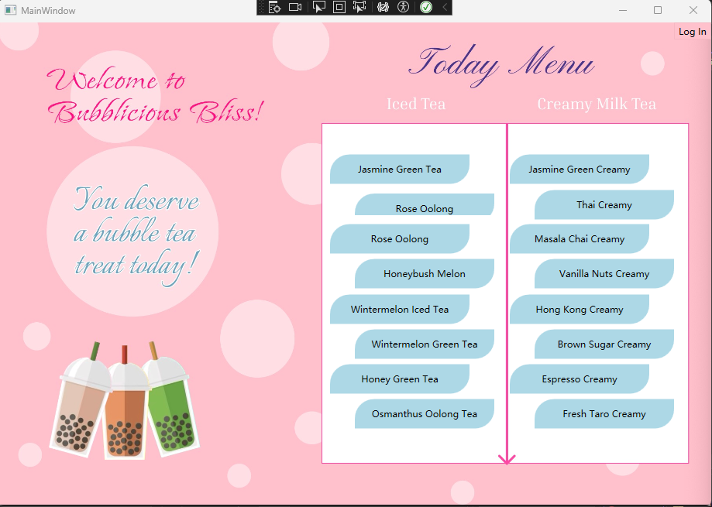

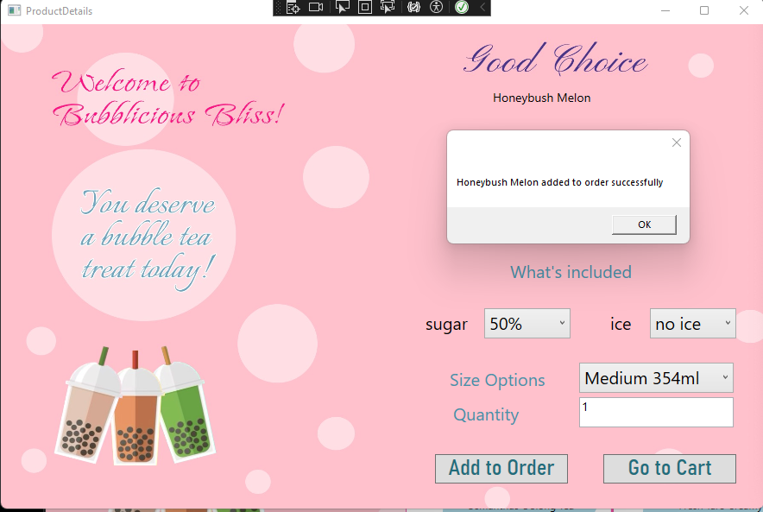



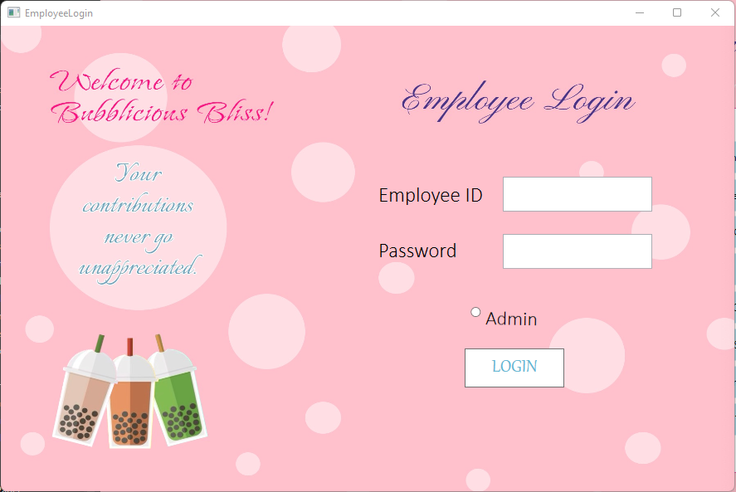

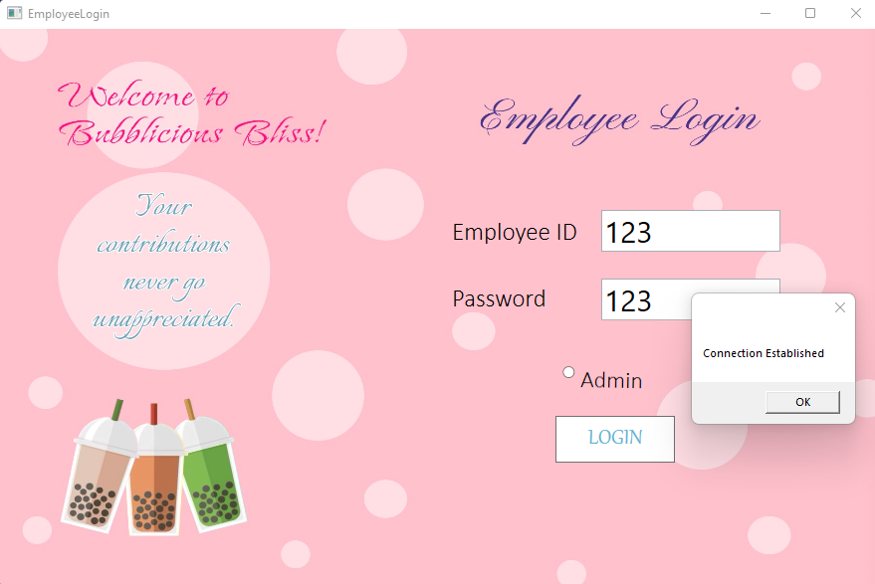

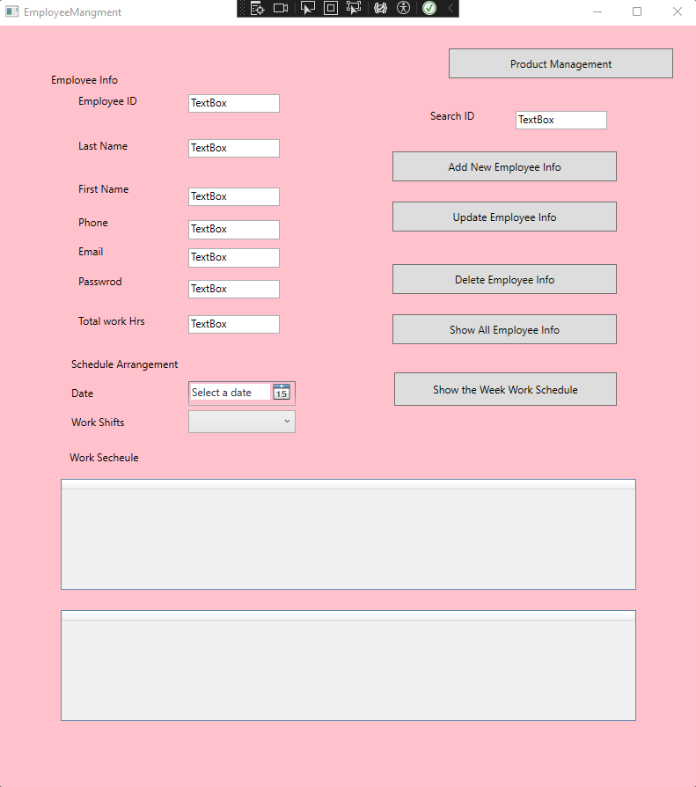

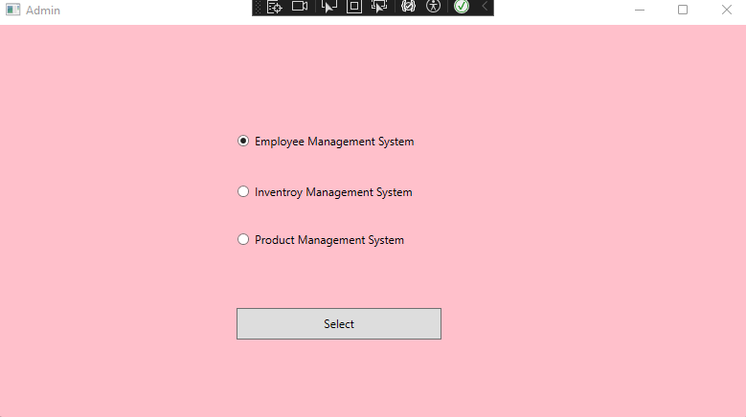

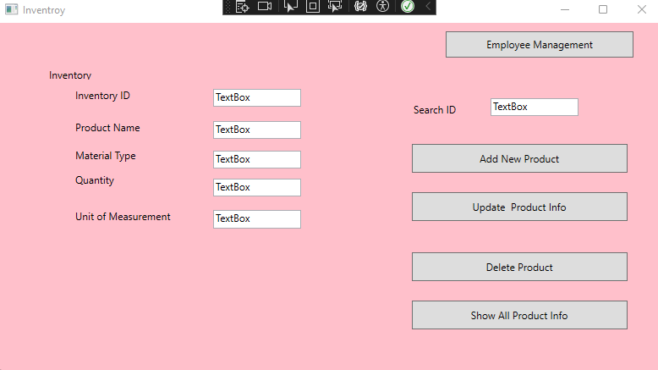

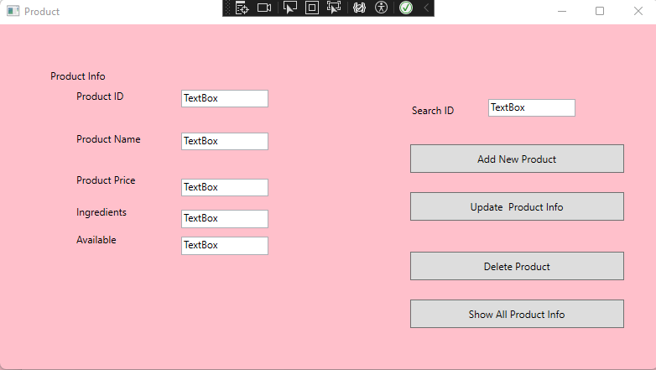

Screenshot of employee management table:

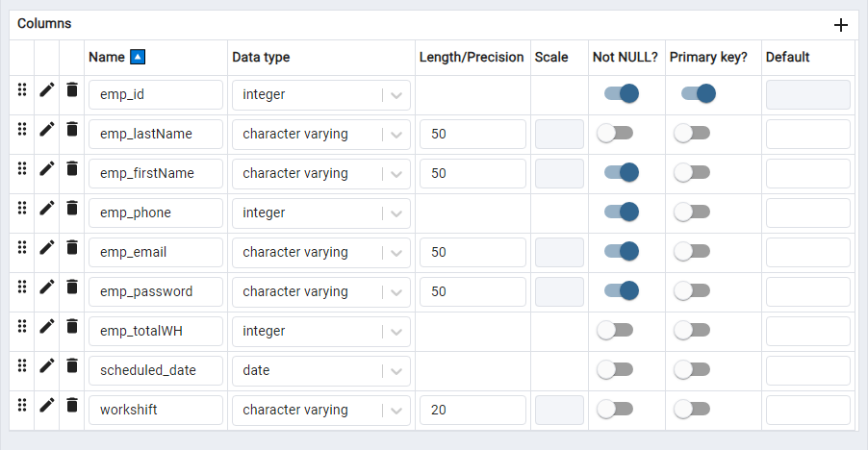

2. Tools Finalized:

Back-end framework: C# with WPF .NetFramework 4.7.2

Database: PostgreSQL

Other Tools:

Front-end framework: Figma for designing the user interface.

Project Roadmap for the Upcoming 4 Weeks:

As we approach the halfway mark of our project, our focus shifts to the development of the admin management system, a critical component in ensuring seamless operations. This encompasses three key facets: employee management, inventory management, and product management. Here's a breakdown of our plans for the next phases:

Employee Management:

In this segment, our goal is to design user interfaces and implement functionalities that empower administrators to manage employee information effectively. This involves the addition, modification, and removal of employee details. Admins will also have the capability to retrieve a comprehensive list of all employees and conduct targeted searches based on employee identification. The array of employee information covers vital aspects such as name, ID number, contact information, total working hours, work schedule, email, password, and more.

Product Management:

The product management aspect will equip administrators with tools to add, update, and delete product information. A comprehensive view of all products will be available. Essential product details, including product ID, name, ingredients, and price, will be part of the management suite.

Inventory Management:

Parallel to product management, our inventory system will allow administrators to handle material inventory efficiently. This involves actions like addition, modification, and deletion of inventory items, with a consolidated display of all inventory information. The user interface will provide insights into inventory ID, name, type, unit of measurement, and other pertinent details.

Technical Implementation:

Database Expansion: We anticipate an expansion of our database with additional tables, particularly for inventory and product management.

Mock Data Setup: To ensure the robustness of our system, we'll set up mock data to thoroughly test the functionalities.

Weekly Breakdown:

Week 1:

Chun Mei: Develop the back-end server-side logic and create necessary tables in the database. Simultaneously, design user interfaces.

Le Le: Integration of the back end with the front-end interface for employee management.

Week 2:

Chun Mei: Implement data storage and retrieval methods, including seamless integration with PostgreSQL.

Le Le: Extend the integration to cover product management.

Week 3:

Collective Effort: Conduct comprehensive integration testing of the entire system, addressing any issues or bugs uncovered during testing.

This roadmap delineates a systematic approach to achieving our milestones over the next four weeks. Each team member's contributions are strategically aligned to optimize efficiency and ensure a cohesive development process.